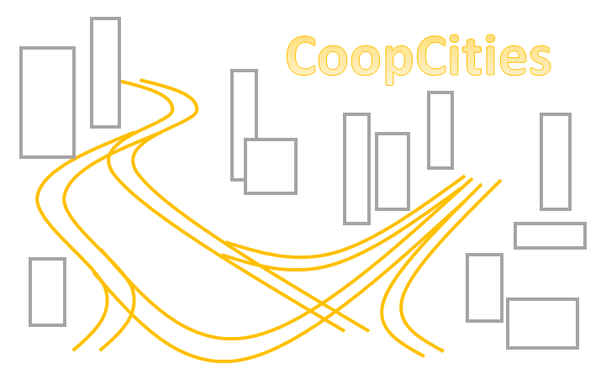

CoopCities:
Learning from urban cities sustainable solutions to deal with the global challenges faced due to COVID pandemic

PR4: CoopCities e-Learning portal

University Paderborn, Chair Business and Human Resource Education II,
Prof. Dr. Marc Beutner
September 2022

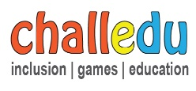




Inhalt
1. The partners of CoopCities who work om PR4 3
2. The main goal of PR4 3
3. The general idea of Project Result 4 of CoopCities 4
4. Devision of work and activities under PR4 5
5. Integration of the learning platform in the project website versus using a separate learning platform 7
6. The use of H5P tasks to create interactive learning tasks 7

Tables

Table 1: The partners working in PR4 of the CoopCities project 3

Figures

Figure 1: A first impression the possible interactive tasks under H5P 8
Figure 2: A first impression of the testing environment of H5P 8
Figure 3: Example of a Multiple Choice task designed with H5P 9
Figure 4: Example of a Fill-in-the-blanks task designed with H5P 9
Figure 5: Example of a wordfinding task in a grid designed with H5P 10
Figure 6: Example of a Flip Card task designed with H5P 11
Figure 7: Creation of H5P tasks under WordPress and possibility to embed in other websites and learning platforms 11

1. The partners of CoopCities who work om PR4
The following table provides an overview on the partner of CoopCities who are foreseen to work on PR 4 the CoopCities e-Learning portal:

Partner | Country | Abbreviation
E-CODE | SLOVAKIA | E-CODE
STANDO LTD | CYPRUS | STANDO
UNIVERSITAET PADERBORN | GERMANY | UPB
EURO-NET | ITALY | EURO-NET
CHALLEDU | GREECE | CHALLEDU
Table 1: The partners working in PR4 of the CoopCities project

2. The main goal of PR4
The aim of the project CoopCities is to enable urban actors (i.e., municipalities and policy makers) to develop necessary skills and competences needed to use when faced with unexpected challenges. In this regard, the project aims to develop an innovative training model for VET trainers/educators to assist them acquiring skills and competences on how to deal with the unexpected global challenges faced in their cities, e.g. the COVID-19 pandemic.

And especially PR 4, the CoopCities e-Learning portal aims to build an e-Learning portal that will become the training tool in the frameworks of the CoopCities project.

The start date of PR4 was originally the 01-01-2022.
The end date of PR4 PR4 was originally the 01-11-2023.

This will have to be adjusted due to the difficulties at the start of the project concerning the work of the coordinator E-Code.

3. The general idea of Project Result 4 of CoopCities
PR4 offers a virtual learning environment for VET trainers and city actors (mayors, local policymakers, city council members, professionals and practitioners, NGOs, international institutions, city decision-makers) as final beneficiaries.

As already mentioned our PR 4, the CoopCities e-Learning portal aims to build an e-Learning portal that will become the training tool in the frameworks of the CoopCities project. It is an innovative way to engage distant learners in the training procedure especially in our days that the COVID pandemic forced people into isolation, without allowing them to physically participate in conventional training. Because of this, e-learning has become very popular lately to give access to knowledge for as many people as possible. The content of the platform will be contributed by all the previous PRs adapted according to become appropriate online training contents.
The learning management system (LMS) used in the platform will use creative innovative features, giving the end-users the possibility to find, among others, training courses well-organized in modules, lecture materials, best practices/case studies, situational reports, social functionalities (forums, etc.). In addition, innovative training material, which will be developed during the project activities' implementation, will be into a format that will facilitate the acquisition of the appropriate knowledge.
The Portal will combine a well-balanced combination of synchronous (virtual classroom for synchronous/online learning for the online collaboration of VET trainers & urban actors using audio/video communication means) and asynchronous learning methods (courses organised in modules, lectures/tutorials, training material organised in eBook format, video narratives, digital case study report cards, the serious game, etc).
Urban actors and interested parties are expected to be trained, as a pilot testing process, by using the portal and its content based on the learning objectives of the project, to build up the users’ trust in technology as a means for learning/training, as well as to advance the quality of VET training/learning through assisting VET trainers to improve their learning, knowledge, and skills, by using technology for training purposes, and to motivate the end-users to
learn e-Learning environments when interactively engaged. The Portal will be developed in such a way to become a valuable educational source on its own, which will be ready for use not only by the VET trainers and urban actors but also independently in other relevant contexts. The Portal will be user-friendly and will support a chat room, giving the opportunity to the registered members to communicate with each other in a common forum. In detail, the Portal will be available in all partners’ languages and it will be the main online training tool for the exploitation of the CoopCities package as part of the innovative training model. The Portal will include the following features: - Courses section based on the PRs, including an evaluation section for learners to test their skills developed; - A registration section in which the users will declare their status (VET trainer, learners); - Based on declarations made at registration, certain sections of the Portal will be available to the users. - The portal will include social modules (i.e. a forum to reinforce the transnational cooperation between users). Impact It will be available in all partners' national
languages (SK, GR, PL&IT), incl. EN and will be managed and updated constantly until the end of the project. PR1, PR2 & PR3 will remain an OER available to the public through the project’s Portal. Due to this, the Portal will safeguard accessing the project results and training material even if interested parties did not have the chance to follow the course while the project was implemented. Individuals will be able to follow the course and self-assess their progress even after the end of the project.
Transferability PR4 structure and final outcome will be made transferable and available to various organisations, professionals and other relevant stakeholders working in the field of sustainable development. It can also inspire the realization of project ideas relevant to sustainable development.

4. Devision of work and activities under PR4
The e-Learning Portal will be led by P3 (University Paderborn - UPB) that - as a University – has an experienced staff in e-Learning platform development. The PR will be a common work of all partners, in close collaboration with the coordinator.

Work will be divided into 7 activities/tasks:
- PR4/A1. Platform design
P3, ALL (M3-M5): as a first step, the characteristics of the Portal will be determined by P3 and presented for approval by the rest of the partners. The logic behind every process will be other relevant information related to IT (domain, supporting server, interface, etc.). This first step will be a full set of specifications for the portal along with the deployment method details.

- PR4/A2. The building of the Portal
P3 (M6-M11): This activity will be implemented simultaneously with PR4/A1 and the development of the portal will mix with its design and remaking of certain parts to meet the approval of the partners and the quality of the project. The development of the Portal will continue and in M12 it will be presented at the mid-term meeting to the partners by P3 in the finalized English version for comments and approval.

- PR4/A3: Integration of the materials
P3, ALL (M12- M16): The materials developed within PR1, PR2, and PR3 will be appropriately adjusted and integrated into the Portal and get ready to use during the courses (C1&C2) with specific attention to the access of the materials in the e-Learning format, adjusted to be easily read and handled by all types of end-users. PR4/A4: Testing the platform and final tuning, P3, ALL (M16-M19): This is the pilot-testing phase of the Portal where partners will involve the VET trainers during C1 and urban actors in C2, in the reviewing process of all features of the Portal to give sufficient feedback for its full completion. P3 will make necessary changes if needed.

- PR4/A5: Translation
P3, ALL (M20-M21): The Portal content, after final corrections, will be translated to all partners’ national languages.
Since Cyprus and Greek speak same language, they will share the workload in translation. Languages are:
- English (as the original version)
- Slovak
- Greek
- German
- Italian

- PR4/A6, Integration of finalised material
P3, ALL (M22): After the training events if necessary and according to the feedback of the participants, changes will be made to all Project Results (PR1-PR4). Changes and translated material will be incorporated into the Portal.

- PR4/A7: Dissemination
P3, ALL (M23-M24): This is the final activity where the Portal will be disseminated by each partner in their own countries during the national multiplier learning events.

5. Integration of the learning platform in the project website versus
using a separate learning platform
In the CoopCities Project the partners have to decide on two possible options.
First, the partnership can use the website to provide the learning platform. It is easy to integrate, text, graphics, videos, interactive tasks into it. Nevertheless, it is much more difficult to integrate synchronous learning options and activities in it.

Secondly, we can use a Moodle Platform (https://moodle.org/?lang=en and https://moodle.com/moodle-4/) as a learning platform to provide the synchronous and asynchronous learning.
“Moodle is a free and open-source learning management system written in PHP.” (Moodle 2022)
“Moodle is a learning platform designed to provide educators, administrators and learners with a single robust, secure and integrated system.” (Moodle 2022)
A user with the role of Administrator is typically in charge of a Moodle site and this would be UPB in the CoopCities project.
UPB will be responsible to provide the partners with the selected system and to support when it comes to entering the learning resources to the website or to Moodle.

6. The use of H5P tasks to create interactive learning tasks
In this part of the guideline we will provide a short overview how you can use H5P to create interactive, online modules to create new types of digital learning and teaching material. A complete overview on the possible tasks we will provide in a specific separate guideline. To get a first impression you can use the free testing environment of H5P on H5P.org.
After a free and quick registration at the homepage of h5p (link: https://h5p.org/https://h5p.org/) you can start to create new learning and teaching materials.
The platform offers 46 types of interactive and digital content types.
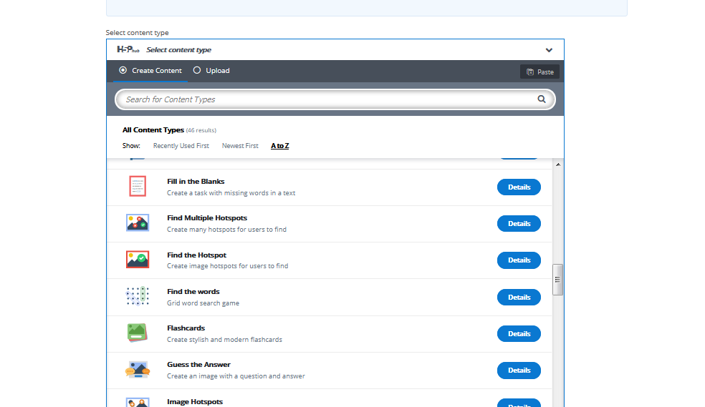
Figure 1: A first impression the possible interactive tasks under H5P

Click on the button “try out H5P” and you can select one of the several types. Here an example of the overview from another project (EDU-VET) in which we used H5P:

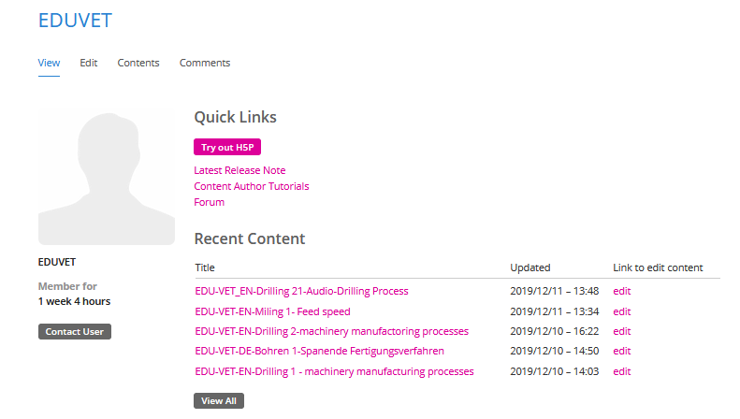
Figure 2: A first impression of the testing environment of H5P

In the following we would like to give some impressions via examples how the tasks will look like.
At the beginning we will provide a look at a classical Multiple Choice task:
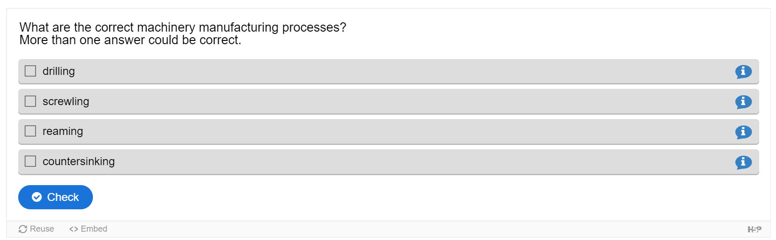
Figure 3: Example of a Multiple Choice task designed with H5P

Find here an example how a fill-in-the-blanks task could look like:
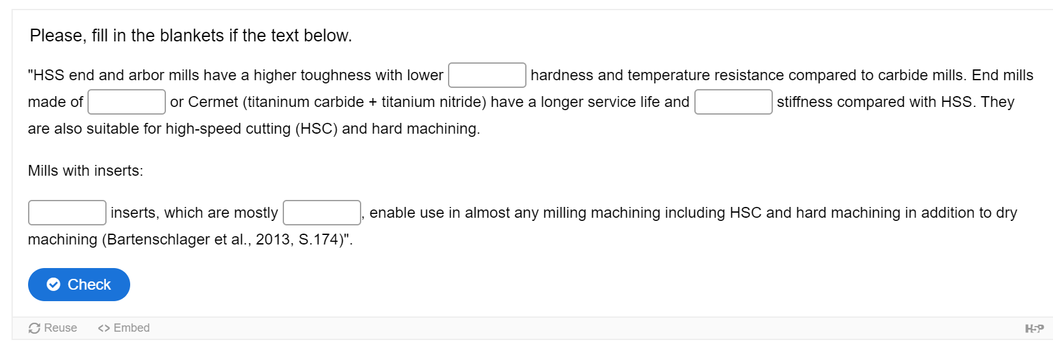
Figure 4: Example of a Fill-in-the-blanks task designed with H5P

And here an example of wordfinding task in a grid:
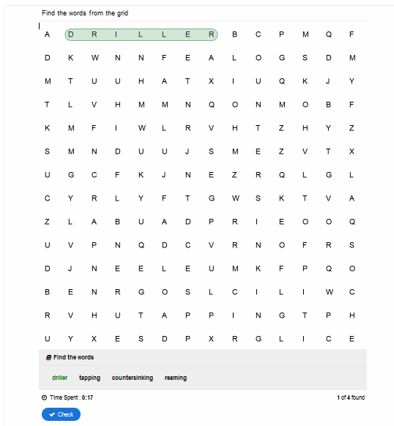
Figure 5: Example of a wordfinding task in a grid designed with H5P
See below an example of flip cards designed with H5P:
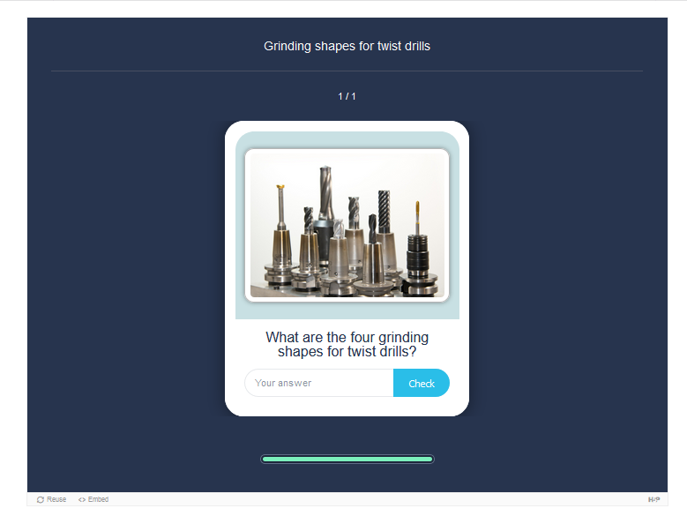
Figure 6: Example of a Flip Card task designed with H5P

The creation process within the project CoopCities will be done via the integration of H5P in the WordPress website of the project which will be provided by UPB. This is totally free of charge, so that we don´t have to use the testing environment of H5P and also not the version of H5P under H5P.com where the users have to pay for the usage. Find below also an example how easy H5P tasks can be integrated or embedded in Websites and learning platforms via an embedding link.

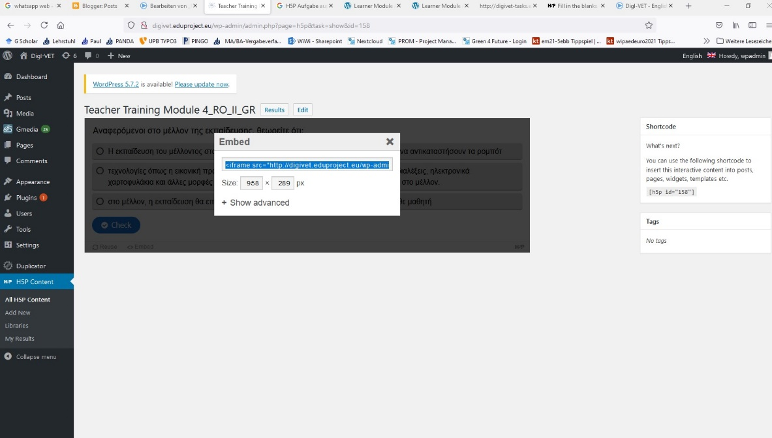
Figure 7: Creation of H5P tasks under WordPress and possibility to embed in other websites and learning platforms

